I used Fusion 360 to model this figure. The height of it overall was 64cm. 9cm was the height of the robot hip, 50cm was the height of the legs, and thickness of the feet were 5cm.

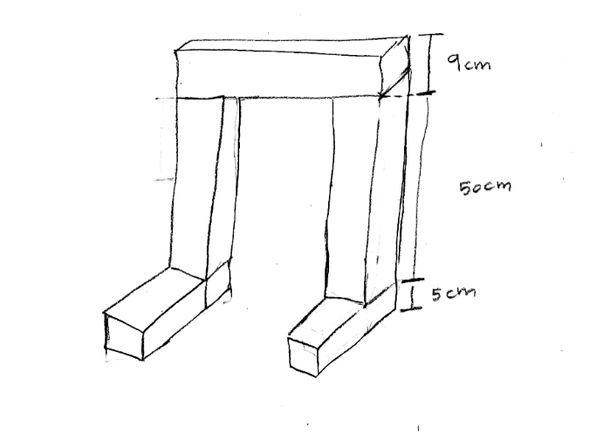

I made the joints a sliding joint for simplicity, the maximum distance a joint can slide is 4.5 which is half of the leg’s thickness(9cm).

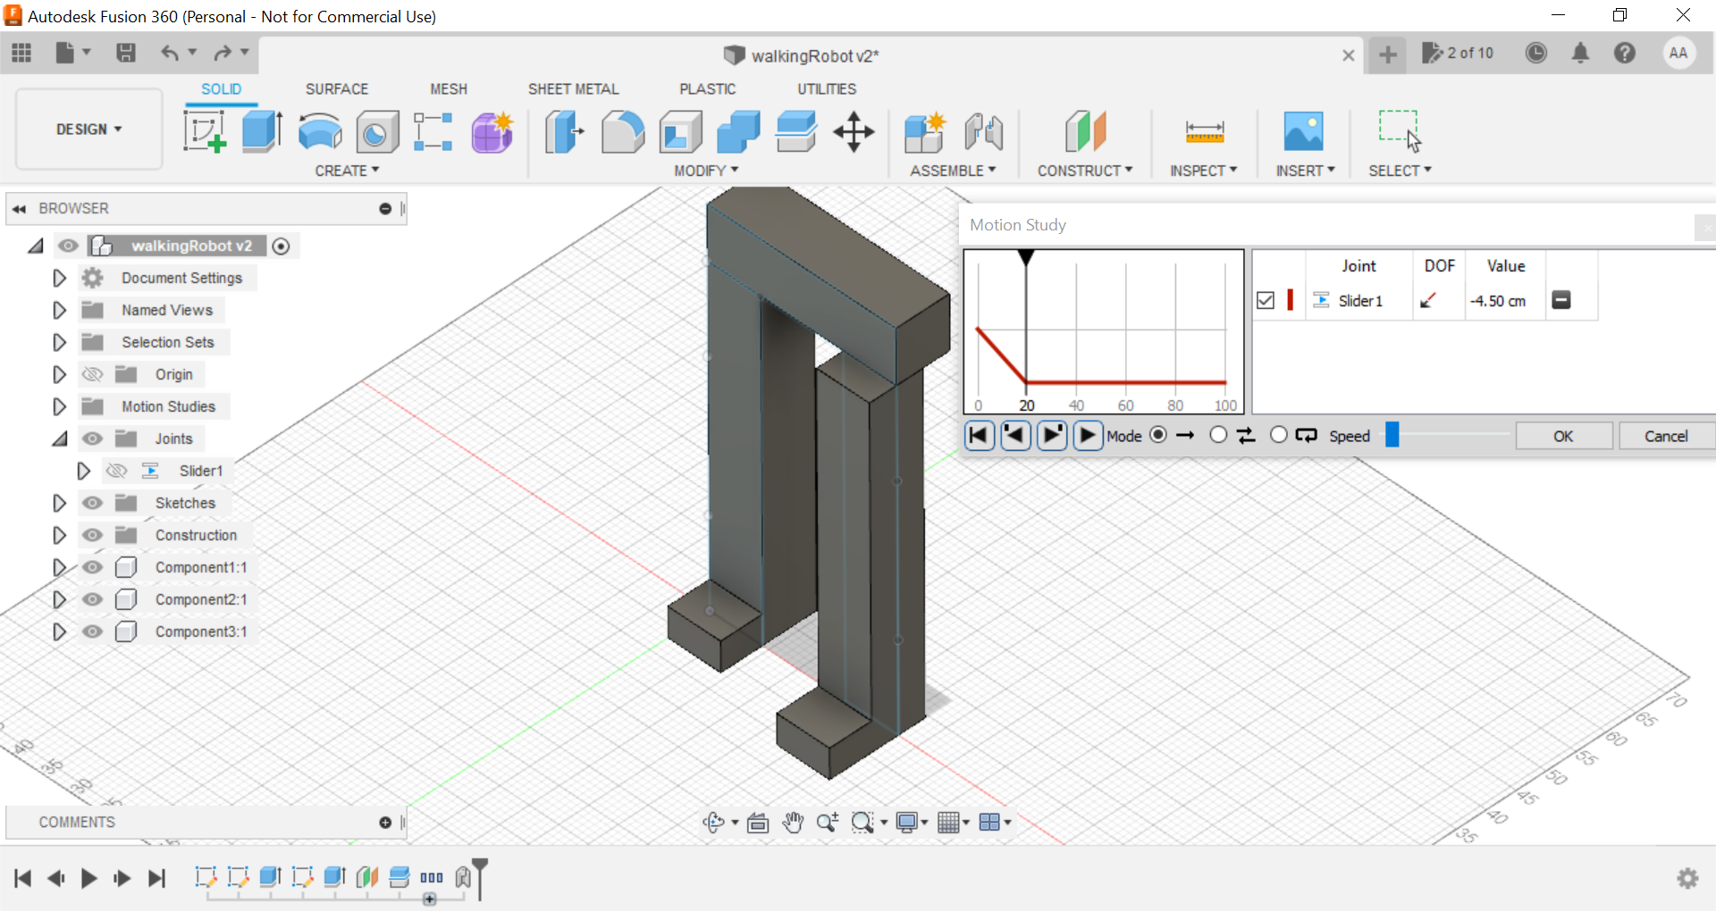

**ONE JOINT:**

I first made it the robot with one joint and simulated the moving motion to see what angle of rotation will result:

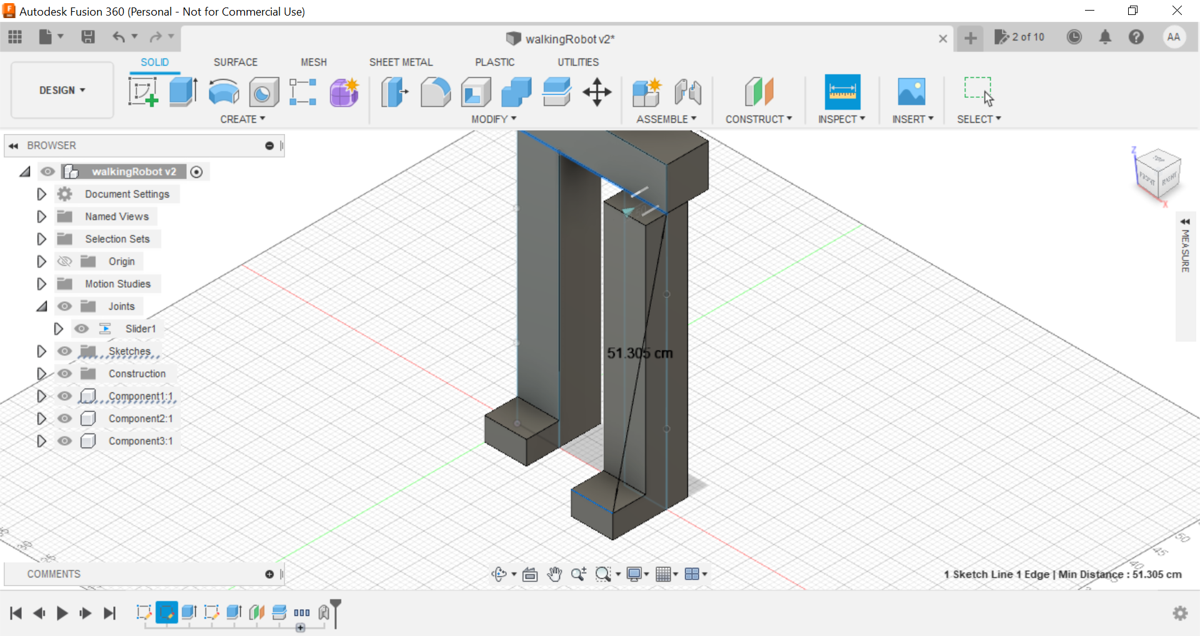

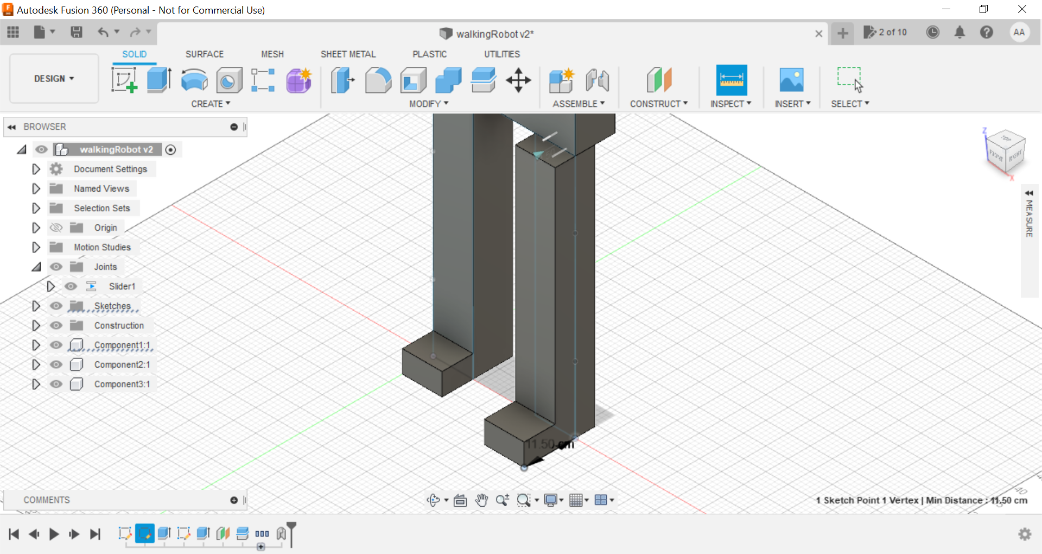

I calcuated theta using sin(theta) = opposite side/ hypotenous = 11.50/51.305

Theta = 12.95 degrees

**TWO JOINTS (AT 25CM):**

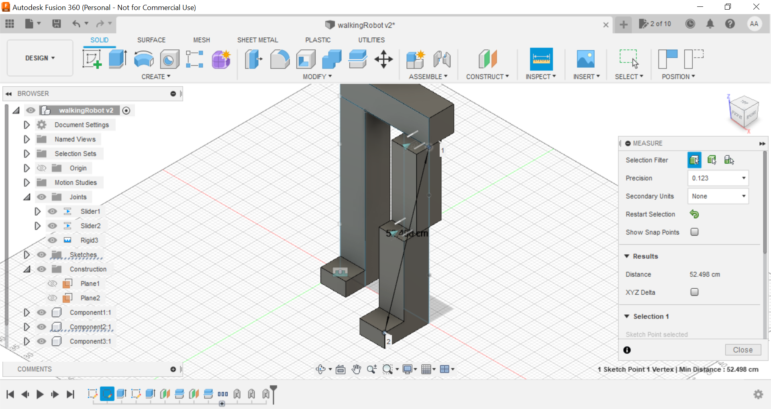

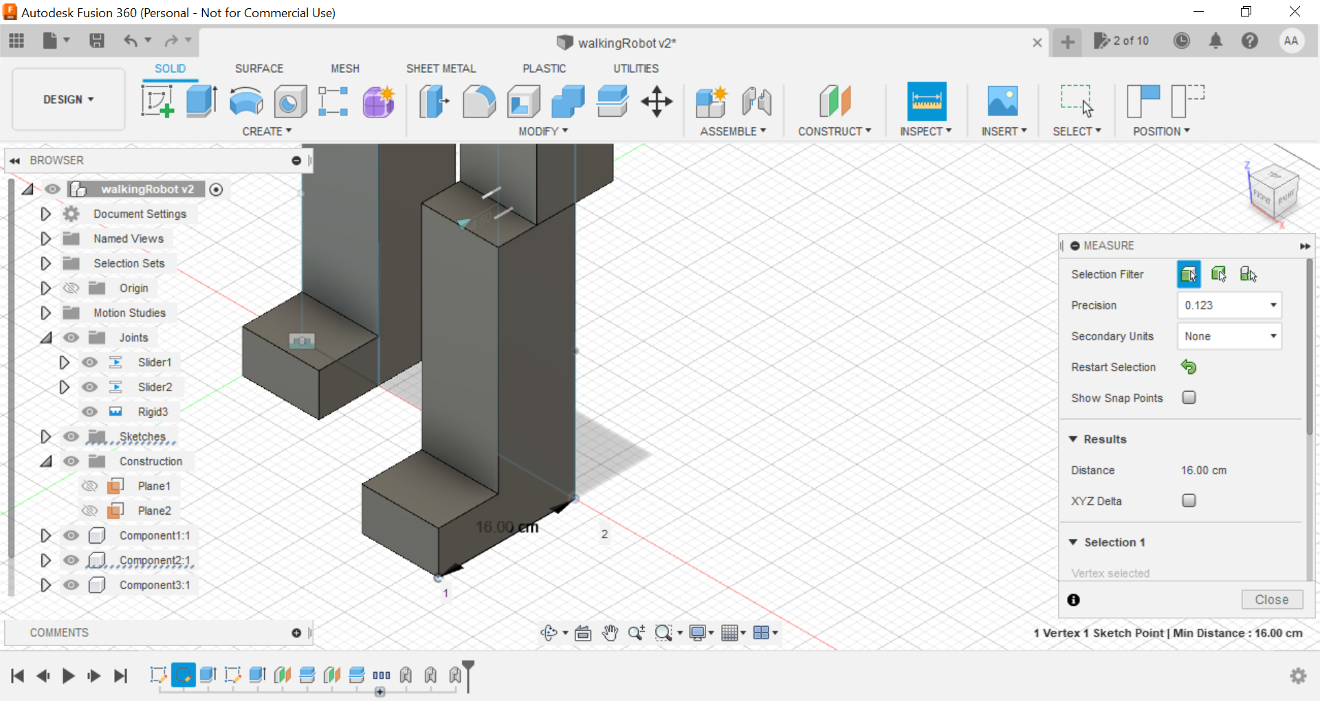

Now I added two joints one at the top (edge of the hip) and another at the middle of the leg (since leg height is 50 so I added joint at 25cm):

Sin(theta) = 16/52.498

Theta = 17.7 degrees

**TWO JOINTS (AT 32CM):** 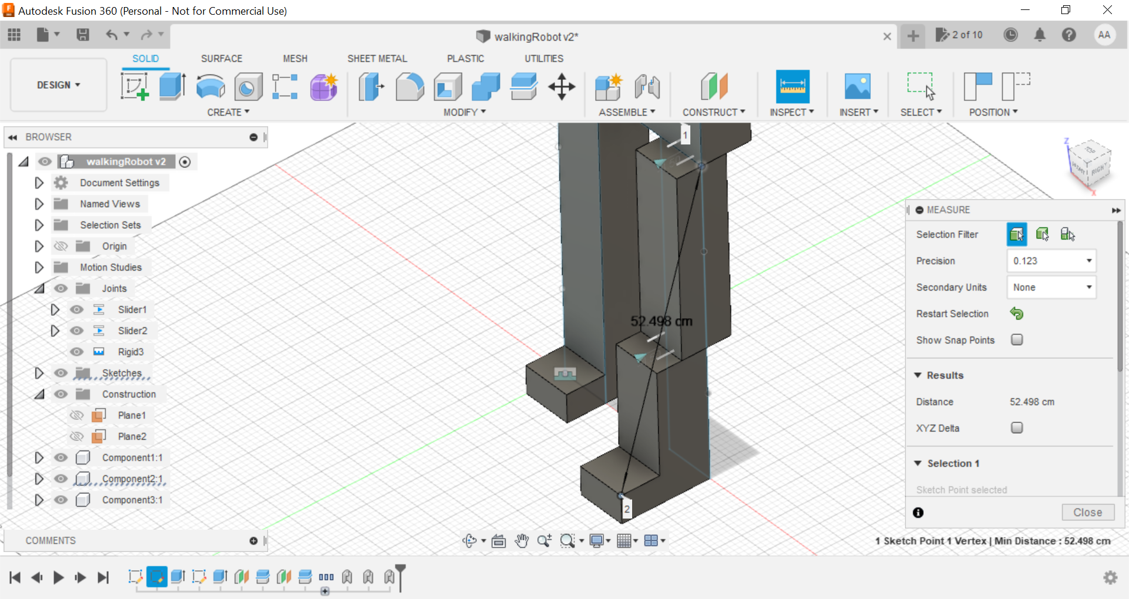

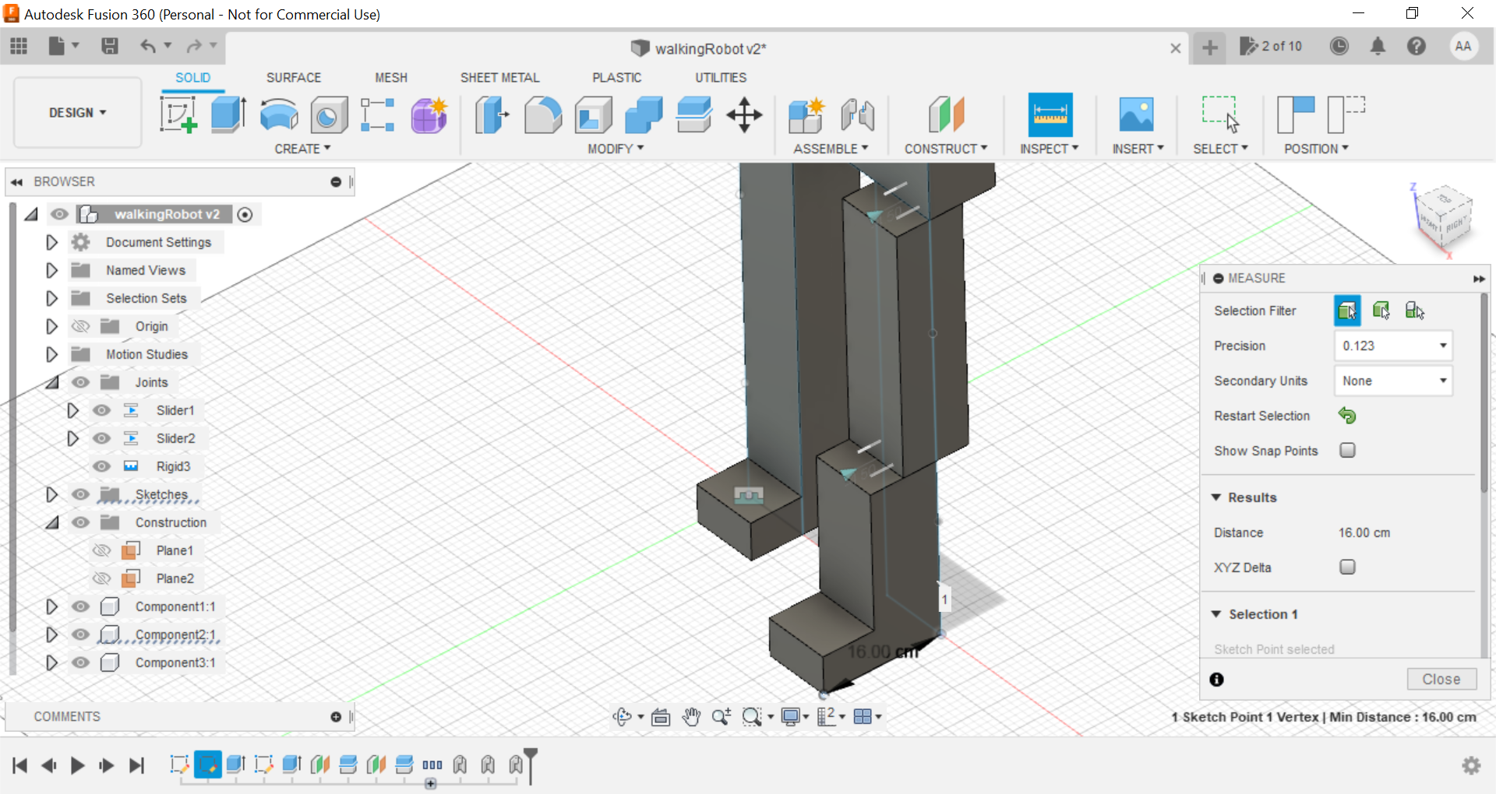

Now I changes the second joint placement I made it closer to the feet of the robot at 32cm from the hip plane:

Sin(theta) = 16/52.498

Theta = 17.7 degrees

**CONCLUSION:**

The two joints at 32cm result are similar to the 25cm one. It is clear that the robot is affected mostly by the number of joints the more joints the larger the degree of rotation. The angle didn’t change with placement because I added a restraint of the sliding joint only to move 4.5cm, so two joints will give us an overall distance of 4.5+4.5 = 9cm and an angle of rotation = 17.7 degrees. A good placement joint would be at the middle of leg height (25cm) so it doesn’t mess with the balance of the robot and at the hip edge to allow more agility.